Behavioral Churn Segmentation & Financial Exposure Analytics Project
Analyst: Deep Roy
Tools: MySQL
Focus:
1. Churn Risk Modeling
2. Financial Impact Analysis
3. Behavioral Segmentation
4. SQL Performance Optimization

Project Overview
Designed and implemented a full-scale customer churn analytics system using advanced SQL techniques. The project begins with rigorous data integrity validation and KPI benchmarking to establish a reliable baseline churn rate.
Built analytical views for feature engineering, including demographic segmentation (age, tenure, credit bands), behavioral metrics, quartile-based balance distribution, and churn lift modeling. Applied multi-factor risk segmentation and exposure indexing to identify high-risk customer clusters and quantify churn drivers.
Developed churn lift analysis across products, activity status, geography, and gender to measure relative risk against baseline performance. Created financial impact assessments to calculate asset loss from churn and simulated retention scenarios to estimate potential savings from targeted interventions.
Optimized performance using composite indexing and execution plan analysis to ensure scalable query efficiency.
This project demonstrates strong capabilities in data validation, feature engineering, risk modeling, financial impact quantification, performance tuning, and executive-level KPI reporting — aligning technical SQL skills with real business decision-making.
Dataset Overview
The dataset contains structured customer-level banking data used to analyze churn behavior. It includes demographic attributes (Age, Gender, Geography), financial indicators (CreditScore, Balance, EstimatedSalary), relationship metrics (Tenure, NumOfProducts, HasCrCard, IsActiveMember), and a binary churn flag (Exited).
Each record represents one customer, enabling segmentation, risk modeling, behavioral analysis, and financial impact assessment. The dataset supports churn rate benchmarking, lift analysis, exposure scoring, and asset-loss simulation to identify high-risk customer segments and quantify business impact.
Problem:
The bank doesn’t know who is likely to leave, why they are leaving, and how much money that churn is costing them.
Analysis Area
- Data Integrity Check: identify total records and duplicate customer IDs
What I created:
my query performs a structural integrity check on the churn table. It compares total rows with distinct customerid values to detect duplicates.
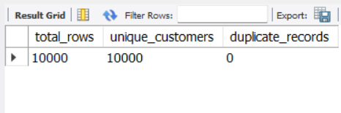
Decision:
Since there are no duplicate records, you can treat customerid as a reliable primary key for joins, dashboards, and modeling.
- Data Validation: detect invalid or unrealistic values in key customer fields
What I created:
my query performs business rule validation. I am checking for unrealistic or invalid values: underage or extreme ages, impossible credit scores, negative tenure, negative salary, and negative balance.
Decision:I conclude the dataset passes basic logical validation and is suitable for further analysis or modeling.
- Baseline KPI View: compute total customers, total churned, and overall churn rate
What the query does:
This view is created to establish the baseline churn rate of the dataset. It calculates the total number of customers, the total number of churned customers (Exited = 1), and the overall churn percentage.
Why it matters:
The purpose of this baseline is to provide a performance benchmark for further analysis. Any segmentation, feature engineering, or predictive model must outperform this baseline to demonstrate real business value. It serves as the foundational metric for evaluating churn risk strategies and model effectiveness.
- Overall churn percentage calculation for performance benchmarking
What I created:
My query calculates the overall churn rate. It counts total customers, sums churned customers (Exited = 1), and computes churn as a percentage.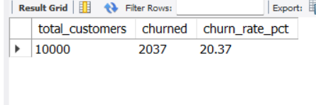
Decision:
churn is significant and not random noise. Retention strategy is necessary. You now have a performance benchmark — any segmentation or predictive model must explain or improve against this 20.37% baseline. Focus next on identifying which customer segments exceed this average risk.
- Feature Engineering View: create analytical segments and derived metrics for advanced churn analysis
The churn_feature_engineering view is developed to enhance analytical capability through structured feature engineering. Raw attributes are transformed into meaningful risk indicators to support deeper churn analysis.
Age and tenure are segmented to capture lifecycle and loyalty patterns. The balance-to-salary ratio measures financial exposure, providing insight into customer dependency on bank assets. Balance quartiles classify customers by relative asset distribution, enabling comparative risk assessment.
This transformation strengthens segmentation analysis and improves the effectiveness of predictive modeling by converting transactional data into behavior-driven analytical features.
- Product-Level Churn Lift Analysis: measure relative churn risk by number of products
Finding :
Customers with 3–4 products show extremely high churn (82–100%) with lift ratios above 4x, while customers with 2 products have the lowest churn (7.6%, lift 0.37). Multi-product holding beyond two products strongly correlates with churn risk.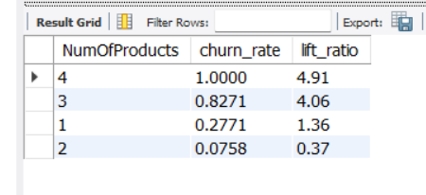
Impact :
Aggressive cross-selling beyond two products may be increasing dissatisfaction or financial burden. High-product customers represent concentrated revenue risk and potential brand damage. If ignored, retention costs and customer acquisition pressure will rise significantly due to preventable churn in high-value segments.
Recommendation :
Reevaluate cross-sell strategy. Conduct satisfaction and usage analysis for customers holding 3–4 products to identify friction points (fees, complexity, service issues). Implement proactive retention outreach for high-product customers, including relationship reviews and benefit optimization. Focus on stabilizing customers at two well-matched products rather than maximizing product count blindly. Align incentives away from volume-driven sales toward long-term customer lifetime value and retention metrics.
- Engagement Risk Analysis: compare churn lift between active and inactive customers
Finding :
Inactive members have a churn rate of 26.9% (1.32x baseline), while active members churn at 14.3% (0.70x baseline). Lack of engagement strongly correlates with higher churn risk.
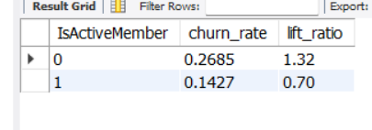
Impact :
Customer inactivity is a leading indicator of attrition. Ignoring engagement signals increases preventable churn and erodes lifetime value. Retention costs will rise if disengaged customers are not identified early. Active engagement clearly reduces churn probability.
Recommendation :
Implement early-warning engagement monitoring. Flag declining transaction frequency, login inactivity, or reduced product usage. Launch targeted reactivation campaigns such as personalized offers, financial reviews, or loyalty incentives. Redesign customer journey touchpoints to increase meaningful interactions. Align retention KPIs with engagement metrics, not just sales targets. Prevent churn by increasing activity before dissatisfaction escalates into exit behavior.
- Geographic Churn Lift Analysis: identify high-risk regions relative to baseline churn
Finding:
Germany shows a significantly higher churn rate (32.4%) with a lift ratio of 1.59, meaning customers there are 59% more likely to churn than average. Spain and France perform below baseline, with churn rates near 16%, indicating geography-driven churn concentration.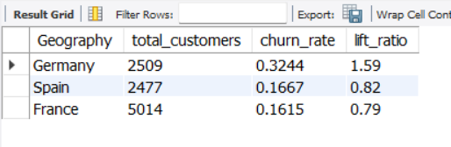
Impact :
Churn risk is heavily concentrated in Germany. Losing customers there will disproportionately damage revenue, customer acquisition ROI, and long-term profitability. Marketing spend may be leaking in that region due to poor retention. Meanwhile, Spain and France are relatively stable, meaning growth strategies could perform better there. Ignoring the German segment will inflate overall churn and increase replacement acquisition costs.
Recommendation :
Treat Germany as a high-risk retention priority market. Conduct targeted retention campaigns—localized offers, loyalty incentives, and proactive customer engagement before churn triggers. Audit pricing, service quality, and competitor positioning specifically in Germany to identify structural dissatisfaction. Allocate more retention budget to Germany instead of spreading it evenly across regions. Simultaneously, double down on customer acquisition in Spain and France where churn risk is lower to maximize lifetime value. Stop treating all geographies equally—rebalance strategy based on risk concentration.
- Gender-Based Churn Differential: measure churn gap compared to overall average
Finding:
Female customers show a 25.1% churn rate, 4.3 percentage points above average, while male customers churn at 16.5%, 4.3 points below average. Churn risk is materially skewed by gender, with females significantly more likely to exit.
Impact :
Retention loss is disproportionately driven by female customers. If ignored, overall churn reduction efforts will underperform because the higher-risk segment is not being addressed directly. Marketing efficiency drops when both genders are treated equally despite unequal risk. This imbalance can distort lifetime value projections and misallocate retention budgets.
Recommendation :
Segment retention strategy by gender immediately. Analyze product usage, service interaction, complaint frequency, and pricing sensitivity specifically among female customers to identify friction points. Launch tailored retention offers or experience improvements rather than generic campaigns. Train customer support to proactively intervene for higher-risk female profiles. At the same time, protect the stable male segment without overspending on unnecessary incentives. Stop using uniform retention messaging—optimize budget allocation toward the segment statistically more likely to churn.
- Credit Score Risk Segmentation: analyze churn performance across credit quality tiers
Finding:
Churn decreases as credit score increases, but the gap is modest. Very Low credit customers show the highest churn (23.73%), while High credit customers still churn at 19.78%. Credit score influences churn, but it is not a dominant driver.
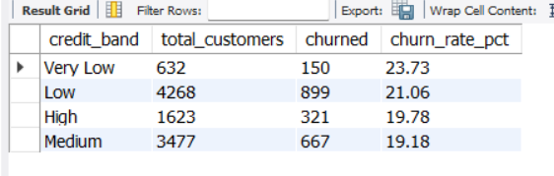
Impact :
Credit risk and churn risk are partially aligned, but not strongly enough to rely on credit score alone for retention strategy. Even high-credit customers leave at nearly 20%, meaning revenue loss is not confined to financially weak segments. Over-focusing on low-credit customers would ignore substantial churn volume in Medium and Low bands.
Recommendation:
Do not treat credit score as the primary churn lever. Instead, use it as a supporting segmentation variable. Prioritize retention efforts based on churn probability combined with profitability, not just credit band. Develop differentiated engagement strategies: financial flexibility or advisory support for Very Low and Low bands, and loyalty-based value enhancement for Medium and High bands. Avoid blanket retention incentives across all credit segments. Focus on understanding behavioral and service-related drivers within each band to create targeted interventions rather than assuming credit score alone explains churn.
- Multi-Factor Risk Segmentation: identify high-risk customer clusters using churn rate and lift
Finding:
Customers holding 3–4 products show extreme churn rates (often 100%), but sample sizes are very small. In contrast, customers with 2 products—especially Mid-Age and Established/Loyal—have the lowest churn (2–6%). Multi-product ownership beyond two strongly correlates with churn risk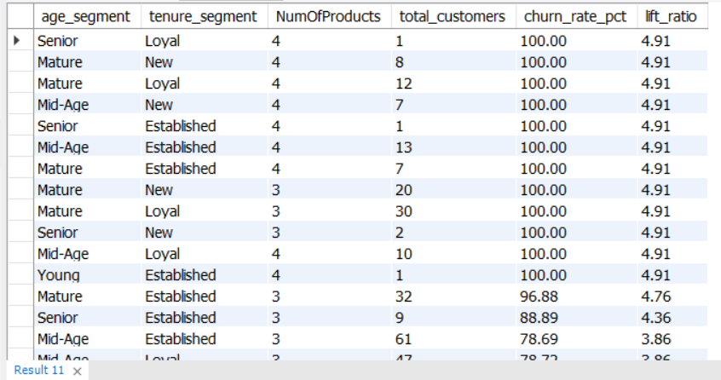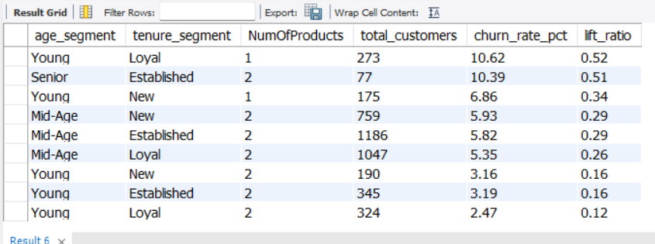
Impact :
Product cross-selling beyond two products appears to backfire instead of increasing stickiness. Over-bundling may create complexity, dissatisfaction, or misaligned product fit. Meanwhile, customers with exactly two products form the most stable and valuable segment. Poor cross-sell strategy could be inflating churn among higher-engagement customers, directly hurting lifetime value and acquisition ROI.
Recommendation :
Re-evaluate the cross-sell strategy immediately. Stop assuming more products automatically increase loyalty. Audit the 3–4 product segment for mis-selling, forced bundling, or poor onboarding. Focus on optimizing the two-product combination as the “sweet spot” retention model. Create structured upgrade paths instead of aggressive bundling. For new customers, prioritize stabilizing them with one strong product before expanding. Retention efforts should target high-product customers proactively, especially new or mature segments, to prevent dissatisfaction-driven exits. Growth must be quality-driven, not volume-driven.
- Risk Exposure Index: assign churn risk score based on key behavioral and demographic drivers
I created this view to combine multiple churn risk indicators into a single weighted risk score per customer. Instead of analyzing separate columns (products, activity, age, credit score), I engineered one composite metric that quantifies churn exposure. This makes segmentation, prioritization, and retention targeting easier and more scalable. It also centralizes My scoring logic in a reusable structure (a view), improving consistency and query efficiency. Essentially, i transformed raw behavioral and financial signals into an actionable churn risk index.
- Behavioral Risk Segmentation: classify customers into exposure tiers for retention prioritization
I created this view to convert a numeric churn risk score into clear, business-friendly segments. Instead of working with raw scores, you categorized customers into High, Moderate, and Low exposure groups. This makes reporting, dashboarding, and retention strategy easier because stakeholders understand segments better than numbers. It also standardizes customer risk classification in one reusable layer. In short, i translated analytical scoring into actionable business segmentation for targeted churn prevention.
- Exposure Segment Performance: evaluate churn rate across risk tiers
Finding:
High Exposure customers show a 36.47% churn rate versus 13.10% for Low Exposure. Although they represent only 31% of customers, they account for 56% of total churn, making them disproportionately responsible for attrition.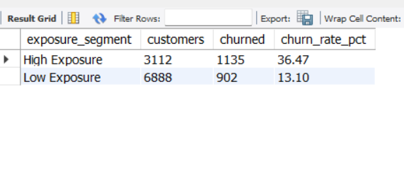
Impact :
High Exposure customers are ~2.8x more likely to churn. This segment is driving the majority of revenue leakage and likely inflating acquisition costs due to replacement needs. If High Exposure customers have higher lifetime value or higher servicing costs, the financial impact is amplified. Ignoring this segment will continue compounding churn-driven revenue loss.
Recommendation :
Immediately prioritize High Exposure customers for targeted retention strategy. Identify why exposure correlates with churn (pricing pressure, product fatigue, over-contact, risk behavior). Deploy segmented retention offers, personalized engagement, and early-warning churn triggers for this group. Consider reducing negative exposure drivers if applicable. Measure retention uplift through controlled experiments and shift budget from broad retention campaigns to high-risk segment intervention. This is a high-ROI opportunity because small churn reduction in this segment will materially reduce overall churn.
- Financial Impact Assessment: measure total assets and percentage lost due to churn
Finding:
Total assets are ~76.49M, and ~18.56M have churned. Asset loss stands at 24.26%, meaning nearly one-quarter of managed assets are tied to customers who exited.
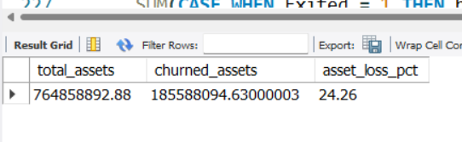
Impact :
This isn’t just customer churn—it’s capital erosion. Losing 24% of assets directly reduces revenue-generating base (fees, spreads, cross-sell potential). If high-balance customers are churning, profitability is being hit disproportionately. Asset churn at this level materially weakens growth, liquidity planning, and long-term valuation. Recommendation :
Shift focus from customer-count churn to asset-weighted retention. Identify high-balance customers at risk and implement proactive relationship management—dedicated advisors, loyalty tiers, preferential pricing, or bundled benefits. Introduce early-warning triggers for declining engagement or balance drops. Reallocate retention budget toward high-asset segments rather than equal treatment across the base. Set asset-retention KPIs (not just customer retention). Even a 5% reduction in asset churn would materially protect revenue and stabilize growth.
- Asset Distribution by Risk Tier: quantify balance concentration and loss across exposure segments
Finding:
Low Exposure holds ~47.36M in assets but loses ~8.20M. High Exposure holds ~29.13M yet loses ~10.36M—despite having fewer customers. High Exposure customers are responsible for the majority of asset loss.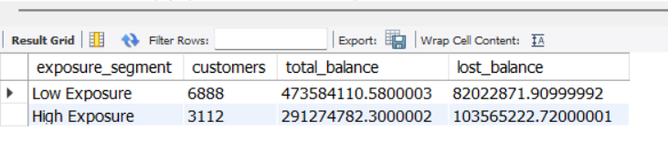
Impact :
High Exposure represents ~38% of total assets but ~56% of total lost balance. This segment is disproportionately destroying value. Asset attrition is concentrated, not evenly distributed. Retention inefficiency here is directly compressing revenue and weakening balance sheet stability.
Recommendation :
Prioritize High Exposure customers with asset-protection strategies. Implement high-touch engagement for top-balance individuals in this segment, including personalized advisory outreach and proactive dissatisfaction monitoring. Redesign exposure drivers if they correlate with friction or risk fatigue. Introduce loyalty incentives tied to asset tenure and balance growth. Track asset-retention by segment weekly, not quarterly. Stop treating churn as a volume problem—this is a concentration problem. Protecting High Exposure assets will yield significantly higher ROI than broad retention campaigns.
- Retention Scenario Simulation: estimate potential asset savings with churn reduction in high-risk segment
Finding:
High Exposure segment currently loses ~10.36M in assets. A modest 5% reduction in churn would reduce loss to ~9.84M, saving ~518K in assets.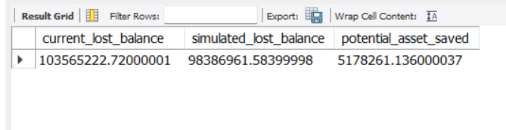
Impact :
A small 5% improvement generates over half a million in retained assets from just one segment. This proves churn reduction here has strong financial leverage. Scaled further (10–15%), the impact compounds significantly, directly protecting recurring revenue and improving balance sheet stability.
Recommendation:
Treat High Exposure retention as a high-ROI investment case, not a defensive cost. Allocate budget specifically to reduce churn in this segment through predictive risk scoring, early intervention outreach, and targeted value reinforcement. Run controlled retention experiments to validate ROI before scaling. Tie incentives of relationship managers to asset retention, not just acquisition. Even incremental improvements materially protect capital, so prioritize focused intervention over broad, low-impact campaigns. This segment justifies aggressive retention spending because the payback is measurable and immediate.
- Executive Summary View: consolidated KPIs for churn rate and financial impact
Finding:
Out of 10,000 customers, baseline churn is 20.37%. Total assets equal ~76.49M, with ~18.56M already lost due to churn—representing significant capital erosion.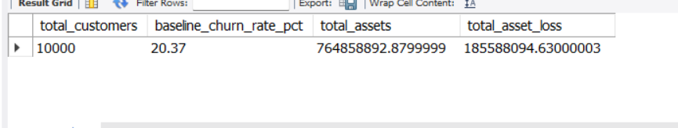
Impact :
One in five customers is leaving, taking nearly a quarter of total assets. This level of churn undermines growth, inflates acquisition costs, and weakens long-term profitability. Without structural retention improvement, asset base and revenue stability will continue declining.
Recommendation :
Shift executive focus from customer growth to asset retention and churn reduction. Establish churn reduction as a top KPI with segment-level accountability. Prioritize high-asset and high-risk segments for targeted retention strategies. Tie leadership incentives to asset retention performance, not just net new acquisition. Invest in predictive churn analytics and proactive engagement models. Stabilizing the existing base will deliver faster ROI than scaling acquisition while leakage remains at 20%+.
Query Performance
I am analyzing query performance using EXPLAIN to evaluate how filtering on NumOfProducts behaves. Then I am improving database performance by creating targeted indexes: a composite index for product and activity filtering, an index for churned balance aggregation, and separate indexes for credit score and age. The objective is to reduce full table scans, accelerate filtering, and optimize aggregation speed for analytical workloads.

